AI-Powered Health Monitoring System

# 1. Project Overview

The AI-Powered Health Monitoring System is a lightweight dashboard built with Streamlit that monitors vital health data including Heart Rate, SpO2 (oxygen saturation), and Temperature. It detects anomalies in health patterns and provides a real-time monitoring solution that can be expanded for telehealth or wearable integration.

# 2. Objectives

- To build a real-time dashboard to monitor patient vitals.  
- To provide visual insights for anomaly detection in health data.  
- To support health monitoring using AI and data visualization.

# 3. Methodology

We used a synthetic dataset simulating patient vitals. The dashboard was developed using Python, Streamlit, and Pandas. It visualizes trends, anomalies, and provides a clean interface. The solution is deployed freely using Streamlit Cloud.

# 4. Results

The deployed app is accessible publicly and showcases a functional health monitoring interface. It can be extended with machine learning models for predictive insights or connected to IoT devices.

# 5. Technologies Used

- Python 3.13  
- Streamlit  
- Pandas  
- Matplotlib  
- GitHub (version control and deployment)  
- Streamlit Cloud (free hosting)

# 6. Screenshots

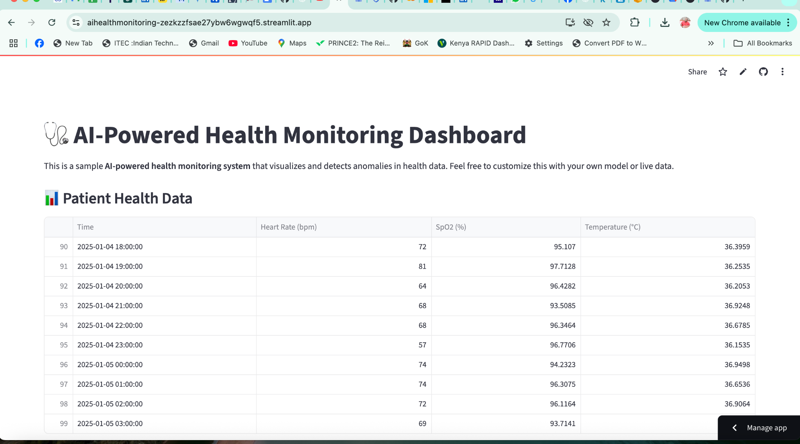

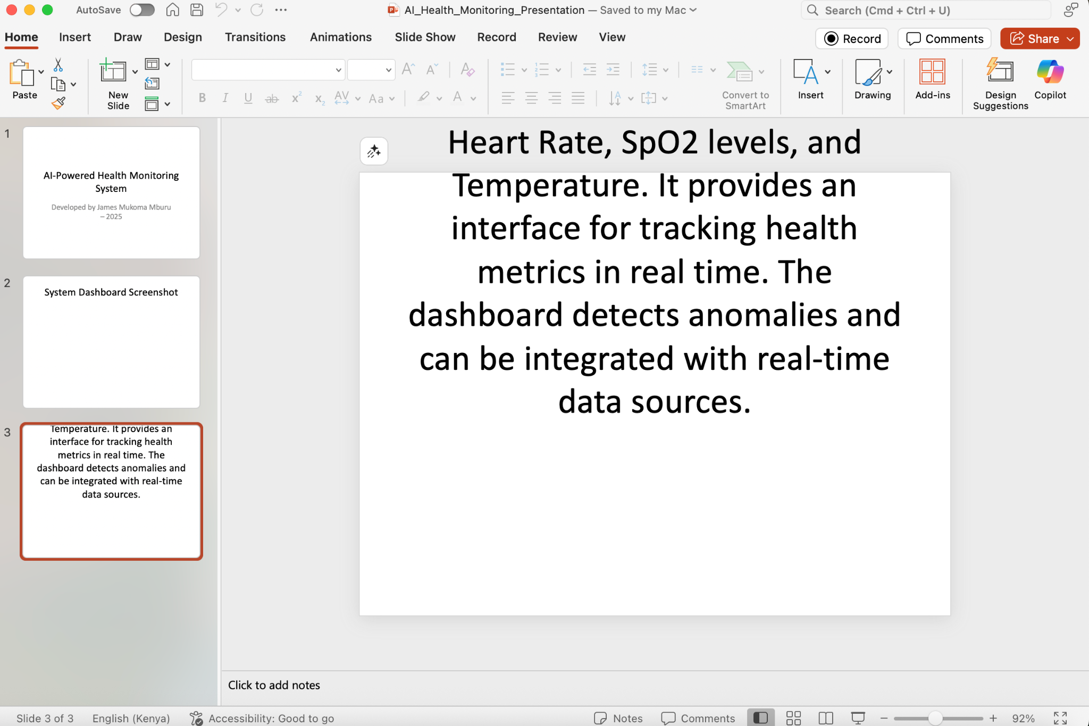

# 7. Conclusion

The AI-Powered Health Monitoring System is a scalable and impactful project aligned with SDG 3 – Good Health and Well-being. Its real-time nature and accessibility on cloud platforms make it suitable for public health integration, especially in remote or underserved regions.